**Project Design Phase-I**

**Solution Architecture**

|  |  |
| --- | --- |
| Date | 03-11-2023 |
| Team ID | NM2023TMID02207 |
| Project Name | HASTAG GENERATOR |

**Solution Architecture:**

Solution architecture is a complex process – with many sub-processes – that bridges the gap between business problems and technology solutions. Its goals are to:

* Find the best tech solution to solve existing business problems.
* Describe the structure, characteristics, behavior, and other aspects of the software to project stakeholders.
* Define features, development phases, and solution requirements.
* Provide specifications according to which the solution is defined, managed, and delivered.

**Example - Solution Architecture Diagram:**

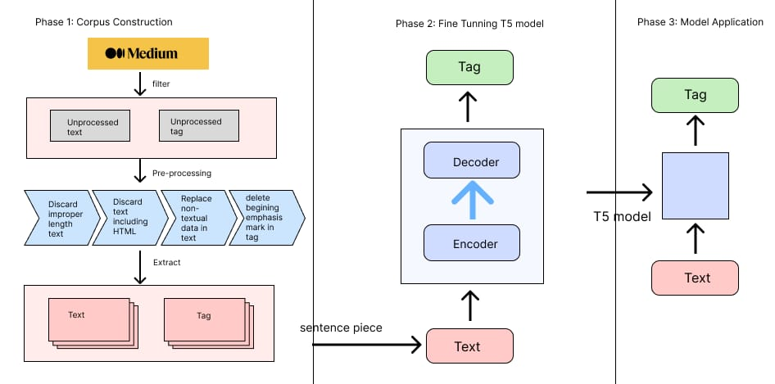

To design a solution architecture for a hashtag generator, consider a cloud-based approach. Utilize a serverless architecture using services like AWS Lambda or Google Cloud Functions to handle hashtag generation triggered by events, such as user inputs or content uploads. Store generated hashtags in a scalable database like Amazon DynamoDB or Google Cloud Firestore. Implement an API Gateway to expose hashtag generation functionality. Use natural language processing (NLP) techniques to enhance hashtag relevance.

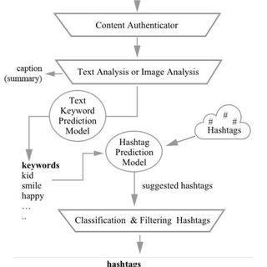

Certainly! Here's a simplified text representation of a solution architecture diagram for a hashtag generator:

**User Interface (UI):**

Input: User enters relevant keywords or content.

Output: Displays generated hashtags.

**Frontend:**

Captures user input and sends it to the backend.

**Backend:**

Receives generated hashtags from the backend and displays them to the user.

**Hashtag Generation Service:**

Takes user input from the frontend.

Utilizes algorithms/rules to generate relevant hashtags.

Sends generated hashtags back to the frontend.

**Data Storage:**

Stores historical hashtag data for analysis and improvement.

**APIs:**

External APIs (e.g., social media APIs) for fetching trending topics or related data to enhance hashtag relevance.

**Analytics:**

Gathers usage analytics for monitoring system performance and user engagement.

**Security:**

Implements security measures to protect user data and system integrity.

This architecture allows users to input content, have it processed by the backend hashtag generation service, and receive relevant hashtags through the frontend. The system may also leverage external data sources and analytics to enhance hashtag suggestions.